Application Form

Energy of nature
30 June – 07 July 2017, Karlovac, Croatia

Partner NGOs from Croatia, Poland, Former Yugoslav Republic of Macedonia, Spain, Albania and Italy. There will be 42 participants in the exchange. The project aims at: Inspiring young participants in the project to its innovative activities contribute to protecting the environment through the use of renewable energy and encourage energy efficiency by encouraging the citizens of their countries to participate more actively

Full Name
Age
Gender
City/town of residence
Email address
Phone number
Are you studying/working/volunteering in an organization, university, formally or informally? If yes, name the organization or university.
What is your role there or field of study?
Special needs (food, health etc.)
Motivation to participate in the youth exchange (personal and professional). Please tell us why you would like to participate in this youth exchange.
Describe your relationship to:
Green jobs, green entrepreneurship, environmental issues, climate change, sustainability issues. Why you are interested in these topics and what experience have you had with these fields.
Volunteer activities. Please tell us what kind of volunteer activities / community activism you have participated in (related to the topic of environment and climate change or other green topics)

Please send the filled application to iep@iep-al.org by 15 May 2017

This project is supported by the Erasmus+ Programme

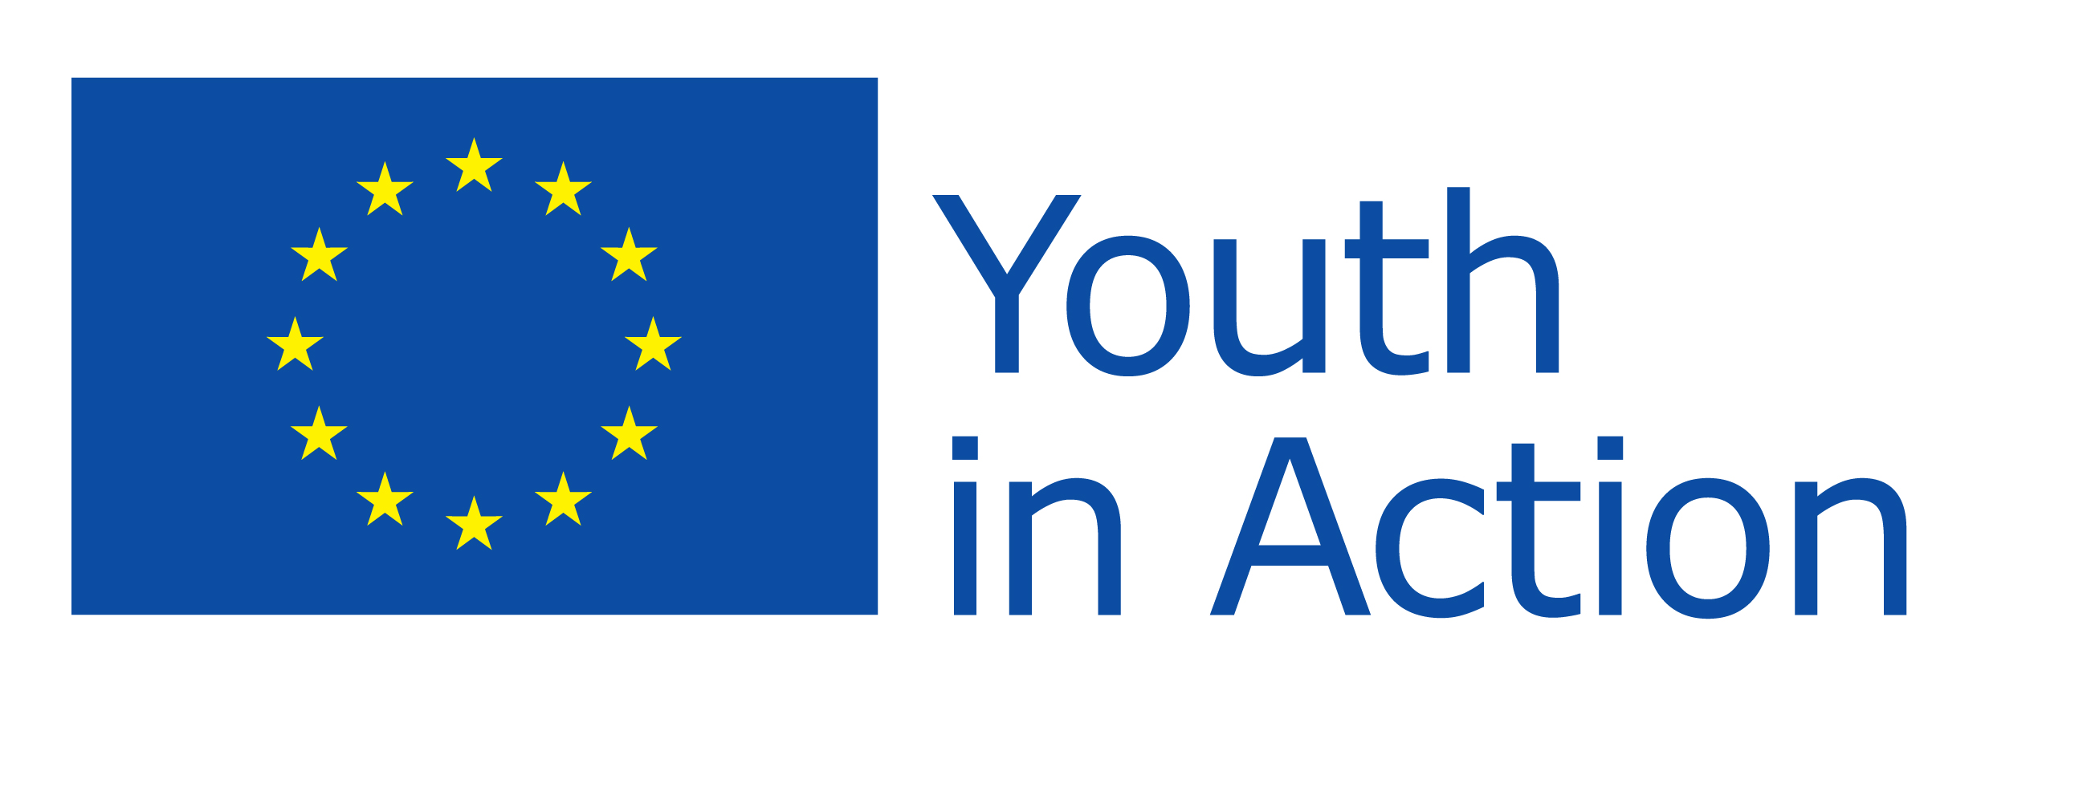

Partners:
